For the following four (4) AP Government FRQ’s - please type them up without using notes or any outside sources. The idea is to get the feeling of writing four prompts in one sitting. So, pick a time over break to sit-down and write out (type, please) answers to all four of the prompts at one time. Good Luck.

- Many people are concerned about large deficits in the federal budget. Rarely does the federal government balance its budget.
  - Define balanced budget.
  - Define federal entitlements
  - Identify an entitlement and explain how entitlements are a barrier to the federal government achieving a balanced budget
  - Describe a consequence of large budget deficits

- Each policy-making institution in the United States federal government is subject to restrictions on its power.
  - Explain how each of the following can restrict presidential power.
- “Power of the Purse”
- The appointment confirmation process
  - Explain how each of the following can restrict congressional power.
- Presidential power as commander-in-chief
- Executive privilege
  - Explain how each of the following can restrict judicial power.
- Enforcement of judicial rulings
- Constitutional amendments

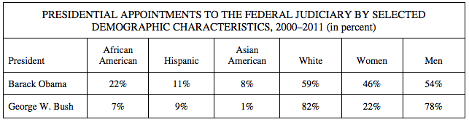

- Presidents consider many factors when nominating candidates to the federal courts, and getting their nominees confirmed is often difficult.

(a) Using the chart above, describe ONE similarity between President Barack Obama’s judicial appointments and those made by President George W. Bush.

(b) Using the chart above, describe TWO differences between President Barack Obama’s judicial appointments and those made by President George W. Bush.

(c) Explain why a president’s party affiliation accounts for differences in presidential appointments to the judiciary.

(d) Describe one way a president can increase the chances of having judicial nominations to federal courts

- The public policy process is complex. The formation, enactment, and implementation of public policy involve many government institutions.
  - Explain the importance of each of the following in the formation of the policy agenda.
    - Media
    - Elections
  - Describe the roles of each of the following in the enactment of public policy.
    - Congressional committees
    - Executive orders
  - Explain the importance of each of the following in the implementation of public policy.
    - Bureaucratic discretion
    - Issue networks OR iron triangles

